**The Solace of Preparing Fried Foods and Other Quaint Remembrances from 1960s Mississippi: Thoughts of the Help**

By: Rohan Maharjan

AGREE

DISAGREE

When my brothers and I have a particularly frustrating day rife with racial insensitivity, we’ll call and say, “Today is a Rosewood day.” Nothing more needs to be said. Rosewood, is a movie set in 1923, and tells the story of Rosewood, a deeply segregated, primarily black town in Florida. A married white woman in nearby Summer, having an affair, is beaten by her white lover. With no other way to explain the marks on her body to her husband, she cries rape and when the townsmen ask her who has done this terrible thing, the white woman, predictably, shrieks, “It was a nigger,” her voice pitched in a way that makes your skin crawl. The white men proceed to lose their minds, surrender to a mob mentality and create a lot of havoc, lynching an innocent black man and tormenting the townsfolk of Rosewood. The angry mob destroys nearly every building, house, and structure in the town. There are some heartbreaking subplots but mostly the story hinges on a little white lie, so to speak. It’s all very distressing and the injustice of what happened in Rosewood is, at times, unbearable because it is based on a true story. The first time I saw Rosewood, I turned to my friend, and said, “I don’t want to see a white person for three days.” She said, “That’s not fair.” Fortunately, it was a Friday so I locked myself in my apartment and by Monday, I was mostly ready to reengage with the world.

[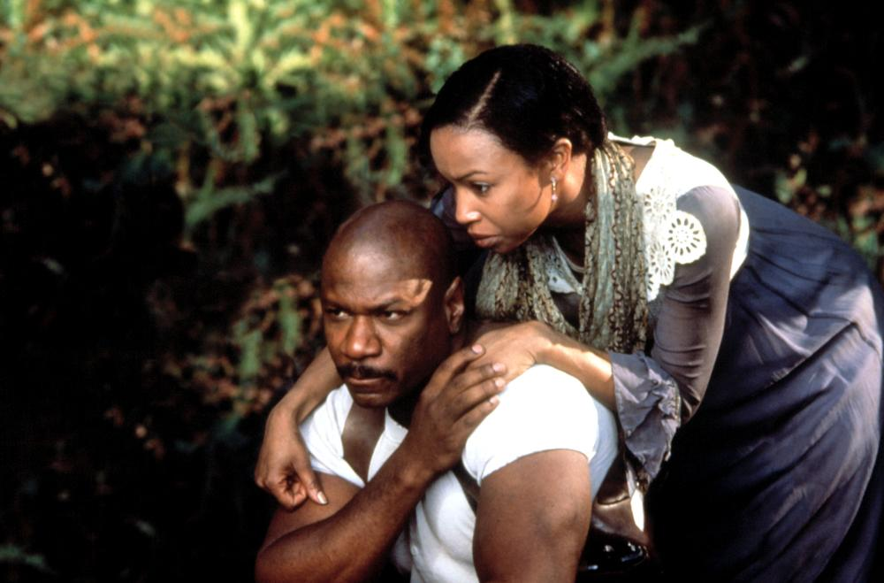](http://therumpus-wpengine.netdna-ssl.com/wp-content/uploads/2011/08/Rosewood.jpg)

If Rosewood demands a three-day window of voluntary segregation, [The Help](http://amzn.to/2s1qnLx) demands three weeks, maybe longer.

*

Watching historical movies about the black experience (or white interpretations of the black experience) have become nearly impossible for the same reason I hope I never read another slave narrative. It’s too much. It’s too painful.  It’s too frustrating and infuriating. The history is too recent and too close. I watch movies like Rosewood or The Help and realize that if I had been born to different parents, at a different time, I too could have been picking cotton or raising a white woman’s babies for less than minimum wage or enduring any number of intolerable circumstances far beyond my control. More than that, though, I am troubled by how little has changed. I am troubled by how complacently we are willing to consume these often revisionist stories of this country’s complex, and painful racial history. History is important but sometimes the past renders me hopeless and helpless.

*

When I first saw the trailer for The Help several months ago I was not familiar with [the book](http://amzn.to/2r6Qulb). The moment I saw the first maid’s uniform grace the screen, I knew I was going to be upset. By the end of the trailer, which contained all the familiar, reductive elements of a movie about the segregated South, I had worked myself into a nice, frothy rage. In the following months, I continued to see the trailer only now it was plastered all over the Internet and on television and the reprinted tie-in book version was heavily hyped, even climbing back to the top of the Amazon bestseller list because this is one of those books nearly everyone seems to love. Last week, I borrowed the book from a friend, read it, raged more.

*

The Help is billed as inspirational, charming and heart warming. That’s true if your heart is warmed by narrow, condescending, mostly racist depictions of black people in 1960s Mississippi, overly sympathetic depictions of the white women who employed the help, the excessive, inaccurate use of dialect, and the glaring omissions with regards to the stirring Civil Rights Movement in which, as [Martha Southgate](http://www.marthasouthgate.com/) points out, [in Entertainment Weekly](http://www.ew.com/ew/article/0,,20516492,00.html), “…white people were the help,” and where “the architects, visionaries, prime movers, and most of the on-the-ground laborers of the civil rights movement were African-American.” The Help, I have decided, is science fiction, creating an alternate universe to the one we live in.

*

Hollywood has long been enamored with the magical negro—the insertion of a black character into a narrative who bestows upon the protagonist the wisdom they need to move forward in some way or as Matthew Hughey defines the phenomenon in a 2009 article in Social Problems, “The [magical negro] has become a stock character that often appears as a lower class, uneducated black person who possesses supernatural or magical powers. These powers are used to save and transform disheveled, uncultured, lost, or broken whites (almost exclusively white men) into competent, successful, and content people within the context of the American myth of redemption and salvation.” (see: Ghost, The Legend of Bagger Vance, Unbreakable, Robin Hood (1991), The Secret Life of Bees, Sex and the City, The Green Mile, Corinna, Corinna etc.)

In The Help, there are not one but twelve or thirteen magical negroes who use their mystical negritude to make the world a better place by sharing their stories of servitude and helping Eugenia “Skeeter” Phelan grow out of her awkwardness and insecurity into a confident, racially aware, independent career woman. It’s an embarrassment of riches for fans of the magical negro trope.

*

The theatre was crowded for the screening of The Help I attended. Women came in groups of three or four or more, many of them clutching their well-worn copies of the book by the same name. As we waited for the movie to start, and a long wait it would be because the projector was malfunctioning (a sign?), I listened to the women around me, certainly well-meaning, many of them of the Golden Girls demographic, chattering about how much they loved the book and how excited they were and how long they had been waiting for this movie to open. I wondered if they were reminiscing about the good old days, then decided that was unfair of me. Still, they were quite enthusiastic. My fellow moviegoers applauded when the movie began and they applauded when the movie ended. They applauded during inspiring moments and gasped or groaned or clucked their tongues during the uncomfortable or painful moments. Their animated response to the movie was not mild. My faith in humanity was tested. I was the only black person in the theatre, though to be fair, that mostly speaks to where I live. As I walked to my car I came to the bitter realization that The Help is going to make a whole lot of money and will be really well received by many.

*

If you go to the theatre without your brain (just leave it in the glove compartment), The Help is a good movie. The production is competent. The cast is uniformly excellent and includes the immensely talented supporting cast of Cicely Tyson, Allison Janney and Sissy Spacek. I would not be surprised if stars Viola Davis and/or Octavia Spencer receive Oscar nominations because not only do they do excellent work in the movie, Hollywood loves to reward black women for playing magical negroes. While I wondered how so many talented people signed on to this movie, the cast is not the problem here. As others have noted, The Help is endemic of a much bigger problem, one where in 2011, the best role available for a two-time Tony Award and one-time Oscar winner like Viola Davis is that of a maid.

Davis, who is always sublime, brings a great deal of intelligence, gravitas and heart to the role of Aibileen Clark, an older maid who has just lost her only son to a mill accident and has worked her whole life as maid and nanny, raising seventeen white children. When we meet her, Aibileen is mourning her son and working as the maid for Elizabeth Leefolt and her daughter Mae Mobley, a chubby, homely girl who is often neglected by her mother. Aibileen’s magical power is making young white children feel good about theyselves. Whenever Mae Mobley is feeling down, Aibileen chants, “You is kind. You is smart. You is important.” She showers the child with love and affection even while having to listen to young white women discuss black people as a subhuman species, deal with the indignity of using a bathroom outside of the main house, and while trying to cope with her grief. Magic, magic, magic. At the end of the movie, Aibileen offers her inspirational incantation to young Mae Mobley even after she is fired for an infraction she did not commit because that’s what the magical negro does—she uses her magic for her white charge and never for herself.

[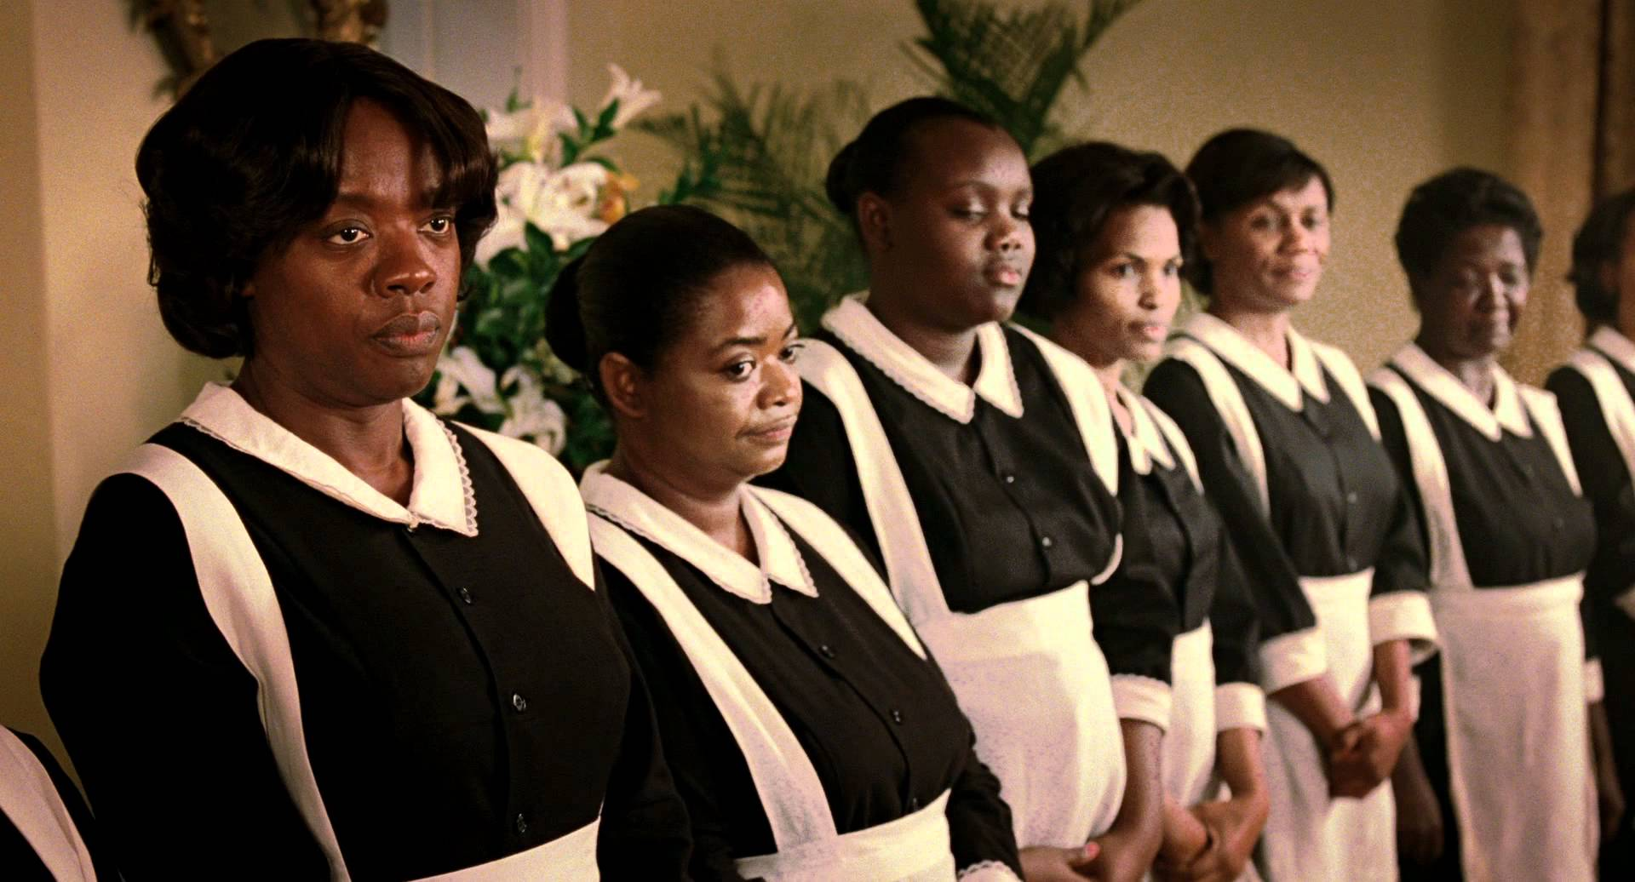](http://therumpus-wpengine.netdna-ssl.com/wp-content/uploads/2011/08/The-Help-1.jpg)

Spencer is also formidable as Minny Jackson, the “sassy” maid (where sassy is code for uppity), who works, at the beginning of the movie, for the petty, vindictive and socially powerful Hilly Holbrook (Bryce Dallas Howard), president of the Junior League. Hilly Holbrook’s claim to fame is among other cruelties, proposing an initiative ordering all white homes to provide separate bathrooms for the “colored” help. When Minny is fired from that job, where she uses her negro magic to look after Hilly’s elderly mother, she goes to work for Celia Foote. The women of the Junior League in Jackson ostracize Celia because she was pregnant when she married, is considered white trash and has committed other petty social sins. Minny uses her mystical negritude to help Celia cope with several miscarriages and learn how to cook and at the end of the movie, the narrative leads you to believe that Celia indirectly empowers Minny to leave her abusive husband as if a woman of Minny’s strength and character couldn’t do that on her own. Then Celia cooks a whole spread for Minny and allows the help to sit at her dining room table just like white folk, aww shucks. Minny asks, “I’m not losing my job?” and Celia’s husband says, “You have a job here for the rest of your life.” Minny, of course, beams gratefully because a lifetime of servitude to a white family, doing backbreaking work for terrible pay is like winning the lottery and the best a black woman could hope for in the alternate science fiction universe of The Help.

Emma Stone plays Eugenia “Skeeter” Phelan who has just returned to Jackson after graduating from Ole Miss. She gets a job as an advice columnist for the local paper but she has bigger aspirations and a whole lot of gumption. We know this because she sasses her mother and doesn’t make finding a man her first priority, no. Her first priority is to give grown black women a voice.  Being back in Jackson forces Skeeter to confront many of the social norms she has taken for granted for most of her life. While her friends baldly treat “the help,” terribly, Skeeter sits silently, rarely protests, but often frowns. Her frown lets us know that racism is very, very bad and that good Southern girls should be nice to their mammies. Skeeter gets the bright idea to tell the stories of the maids who spend their lives cleaning white people’s houses, raising white people’s babies. Stone is charming and believable even if the character she plays is willfully ignorant. The charm, though, grates because it is fairly obscene to imagine that this wet behind the ears lass would somehow guide the magical negroes to salvation through the spiritual cleansing of occupational confession. When Aibileen reminds Skeeter they shouldn’t be seen together, Skeeter briefly educates herself on Jim Crow laws and then ignores whatever she learned, imposing herself on Aibileen’s bewildering good will, urging Aibileen to share her story about what it’s really like to be a maid in Jackson, Mississippi, as if the truth were not plainly obvious. At the end of The Help, Skeeter offers to turn down her dream job in NYC so she can stay and “protect” Aibileen and Minny. We’re supposed to see this as a heartwarming gesture but it only brings the movie’s overall condescension into bitter relief.

*

The Help is, in the absence of thinking, a good movie, but it is also an unfairly, emotionally manipulative movie. There are any number of times during the interminable two hours and seventeen minutes running time when I felt like my soul would shrivel up and die. I was devastated by all of it. Everyone around me cried openly throughout most of the movie. My eyes were not dry. I am certain we were often crying for different reasons.  Every transgression, injustice and tragedy was exploited so that by the end of the movie it was like the director had ripped into my chest, torn my heart out and jumped up and down on it until it became a flattened piece of worn out muscle—cardiac jerky, if you will.

The movie is emotionally manipulative but in a highly controlled way. The Help provides us with a deeply sanitized view of the segregated south in the early 1960s. There are many unpalatable moments but they are tempered by a great deal of easy humor or contrived touching emotional moments. The movie gives the impression that life was difficult in Mississippi in the 1960s for women, white and black, but still somewhat bearable because that’s just how things were.

The implausibilities in the science fiction universe of The Help are many and wild. Certainly, that happens in most movies, especially these days. What makes these implausibilities offensive in The Help is that most of us know better. We know our history. There is not enough height in the atmosphere for us to suspend our disbelief.

*

If you do bring your brain to The Help, the movie is worse than you might imagine. Seeing The Help through a critical lens was excruciating.  At one point, while teaching Celia Foote to make fried chicken, Minny says, “Frying chicken tend to make me feel better about life.” That a line about the solace found in the preparation of fried foods made it into a book and movie produced this decade says a great deal about where we are in acting right about race. We are nowhere. That line was one of many that made me cringe, cry, roll my eyes, or hide my face in my hands. To say I was uncomfortable is an understatement. Little things also grate. The over-exaggerated dialect spoken by the maids evokes cowed black folk shuffling through their miserable lives singing Negro spirituals. In Aibileen’s home, for example, there are pictures of white Jesus and her recently deceased son. After Medgar Evars is shot and JFK attends his funeral, the camera pans to the wall where a picture of JFK joins the other two, not say, a picture of Medgar Evars himself or another civil rights leader. In another subplot, of which there are many, Skeeter’s childhood nanny, Constantine (Cicely Tyson) is so devastated after being fired by the white family for whom she worked for over twenty-seven years, she dies of a broken heart. The gross implication is that her will to live came from wiping the asses and scrubbing the toilets of white folks for most of her life. It’s this kind of white fantasy wish fulfillment that makes the movie so frustrating.

Men, black and white, are largely absent from the movie. White men are absented from any responsibility for race relations in 1960s Mississippi. The movie is devoid of any mention of the realities of the sexual misconduct, assault and harassment black women faced working for white men. We see nary an unwelcome ass grab. I don’t think lynching was brought up once. We don’t know how Aibileen came to have a son so we’re left to assume, because she is magical, that her child’s conception was immaculate. Minny’s husband, who we never see, is abusive. We hear her being abused during a phone call and toward the end of the movie, we see Minny’s bruised face, but we never see the man, Leroy, who has committed these acts of violence. There is also the bizarre subtext that the woman with sass is the one who has to be kept in line through brutality. As in most popular portrayals, black men are dealt with in depressing, reductive ways when they are dealt with at all. This movie shamelessly indulges in the myth of the absent black man. The actual consequences of black women consorting with a young white girl were glossed over as merely inconvenient instead of mortal. The white women are portrayed as domestically tyrannical while living highly constrained lives as desperate Southern housewives (so we can sympathize).

I could go on and on and on. I won’t. It has been twenty-nine hours since I saw The Help. I am still in isolation.

*

Race is handled ineffectually in movies and fiction all the time. I have become accustomed to this reality. And yet. I have struggled with writing about The Help because there is something more to my anger and frustration.

At first I thought I resented that a deeply flawed book has sold more than three million copies, spent more than 100 weeks on the best seller list, and is a major motion picture. The reach of the malignant message of The Help is far indeed but books I don’t like do well all the time. I don’t lose sleep over it. I also cannot deny that the book and movie have their moments. There were times when I laughed or was moved, though certainly, those instances were few and far between.

I think of myself as progressive and open-minded but I have biases and in reading and watching The Help, I have become painfully aware of just how biased I can be. My real problem is that The Help is written by a white woman. The screenplay is written by a white man. The movie is directed by that same white man. I know it’s wrong but in my heart, I think, “How dare they?”

[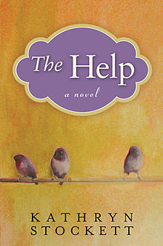](http://therumpus-wpengine.netdna-ssl.com/wp-content/uploads/2011/08/The-Help.jpg)

Writing across race (or gender, sexuality, and disability) is complicated. Sometimes, it is downright messy. There is ample evidence that it is quite difficult to get difference right, to avoid cultural appropriation, reinscribing stereotypes, revising or minimizing history, or demeaning and trivializing difference or otherness. As writers we are always asking ourselves, “How do I get it right?” That question becomes even more critical when we try to get race right, when we try to find authentic ways of imagining and re-imagining the lives of people with different cultural backgrounds and experiences. Writing difference requires a delicate balance and I don’t know how we strike that balance.

I write across race, gender, and sexuality all the time. I would never want to be told I can’t write a story where the protagonist is a white man or a Latina lesbian or anyone who doesn’t resemble me. The joy of fiction is that in the right hands, anything is possible. I firmly believe our responsibility as writers is to challenge ourselves to write beyond what we know as much as possible. When it comes to white writers working through racial difference, though, I am conflicted, and, I am learning, far less tolerant than I should be. If I take nothing else from the book and movie in question, I know I have work to do. For that reason alone, I don’t regret engaging with these texts.

I don’t expect writers to always get difference right but I do expect writers to make a credible effort. The Help demonstrates that some writers shouldn’t try to write across race and difference. Kathryn Stockett tries to write black women but she doesn’t try hard enough. Her depictions of race are almost fetishistic unless they are downright insulting. At one point in the book, Aibileen compares her skin color to that of a cockroach, you know, the most hated insect you can think of. Aibileen says, staring at a cockroach, “He big, inch, inch an a half. He black. Blacker than me.” That’s simply bad writing but it’s an even worse way of writing difference. If white writers can’t do better than to compare a cockroach to black skin, perhaps they should leave the writing of difference in more capable hands. In The Help, Stockett doesn’t write black women. She caricatures black women, finding pieces of truth and genuine experience and distorting them to repulsive effect. She makes a very strong case for writers strictly writing what they know, not what they think they know or know nothing about.